
a
Company
Logotype

Cone Beam Computed Tomography- Report



Porur Dental X-rays & CBCT

Patient Name : Mrs. Shathurini | Date of Report : 27.04.2024
Age/ Gender : 68 years/ Female | Region of Interest : CBCT Full Skull
Referring doctor: Dr. B. Naveen Kumar | Indication : Implant assessment
Clinical Notes: Nil
PATIENT INFORMATION

CBCT- Full Skull provided
CBCT – IMAGE DETAILS

RADIOGRAPHIC INTERPRETATION

- Partially edentulous maxillary and mandibular alveolar ridge with missing teeth: 16, 17, 18, 27, 28, 37, 38, 47, 48.
- Root Stumps: 15, 25, 26.
- The maxillary and mandibular alveolar ridge are present with normal trabecular pattern.
- Discontinuity in relation to the floor of the right maxillary sinus is evident.
- Complete hyperdense opacification of the right maxillary sinus and more than 2/3rd hyperdense opacification of the left maxillary sinus is present.

IMPLANT ASSESSMENT

 | 15 region | 16 region | 17 region | 25 region | 26 region | 27 region
Sub-Crestal (in mm) | - | - | - | 8.8 | 10.6 | 8.1
Mid- Crestal (in mm) | - | - | - | - | - | 8.2
Distance between the alveolar ridge and floor of the maxillary sinus (in mm) | 1.3 | 2 | 0.6 | 2.5 | 4.9 | 6.2

 | 37 region | 47 region
Sub-Crestal (in mm) | 6.2 | 4
Mid- Crestal (in mm) | 9.5 | 4.8
Distance between alveolar ridge and the inferior alveolar nerve canal (in mm) | 12.5 | 14.1
Distance between alveolar ridge and the inferior border of mandible (in mm) | 24.4 | 26.5

RADIOGRAPHIC IMPRESSION

- Partially edentulous maxillary and mandibular arch.
- Bimaxillary sinusitis.

Kindly correlate with clinical findings


IMAGES FOR REFERENCE

RECONSTRUCTED PANORAMIC VIEW
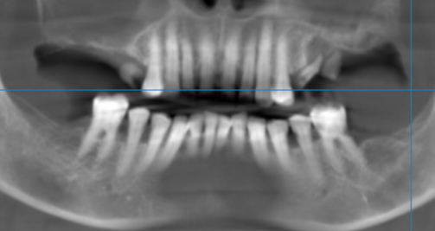

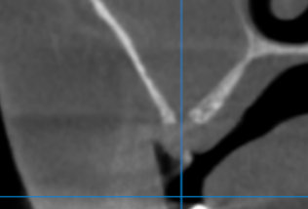
Discontinuity of the floor of the right maxillary sinus

3-DIMENSIONAL VIEW

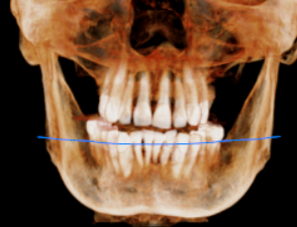
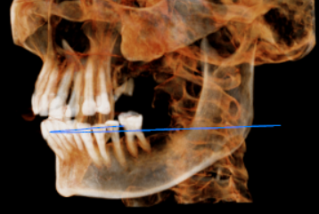

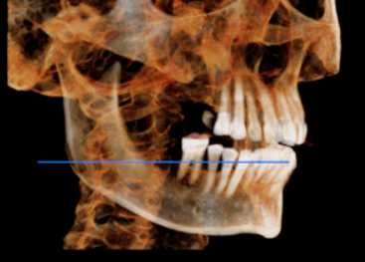

CROSS SECTIONAL VIEW

15 region | 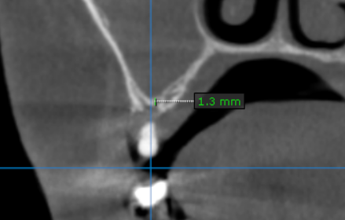
16 region | 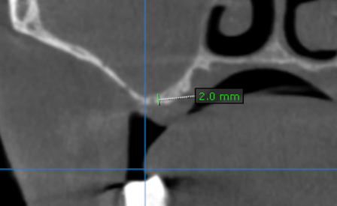
17 region | 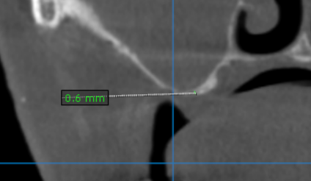
25 region | 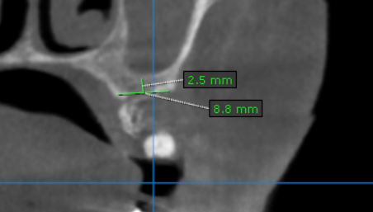
26 region | 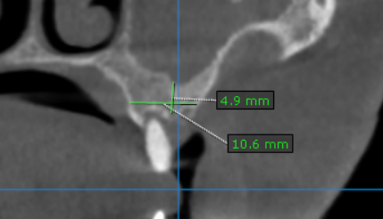
27 region | 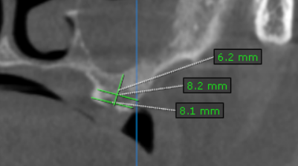
37 region | 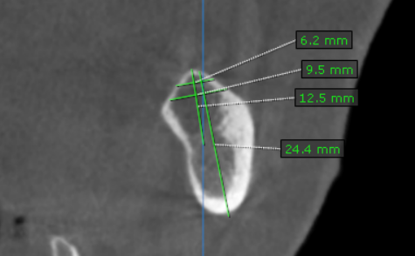
47 region | 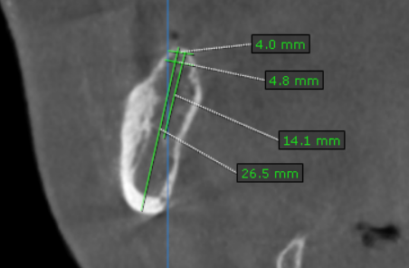

**** End of report ****

